Celebrate 100 Years of the

Progressive Women’s Club &

Valley Center Public Library

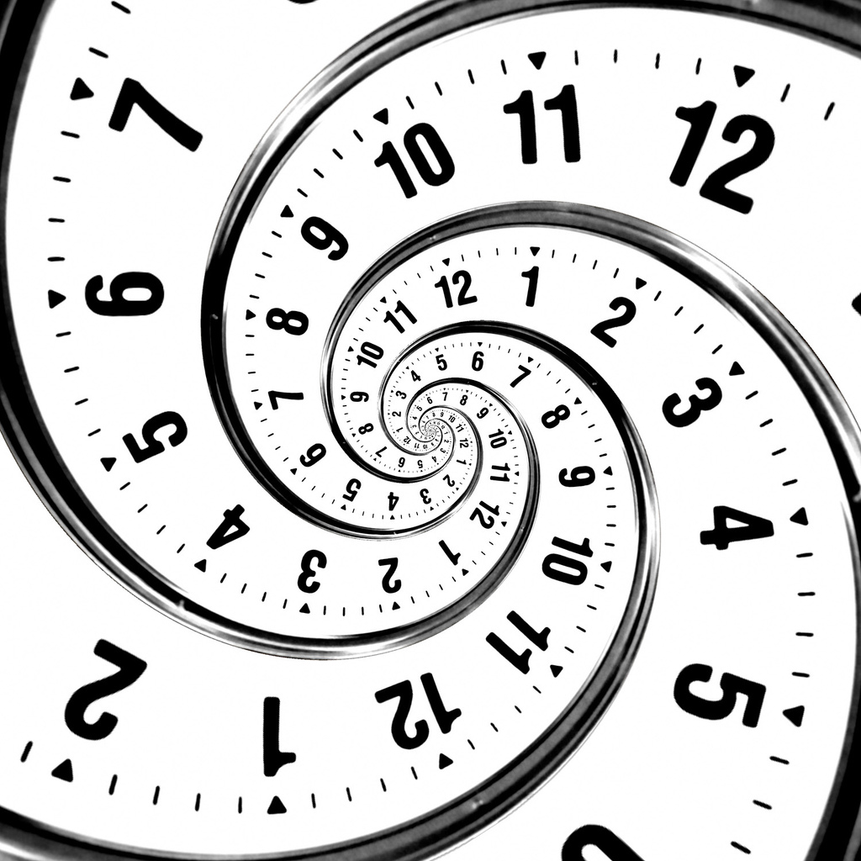

~ Reading Challenge 2023 ~

Welcome to our year-long 2023 reading challenge, celebrating the 100th year of our Valley Center Library!
Established in a drugstore in 1923, the Valley Center Library was managed and funded by volunteers known as the Progressive Women’s Club, later to become the Friends of the Library. Trunks of books were rented from the State Library of Kansas for citizens to check out. The location of the Library was moved several times over the years before the Club acquired the first Library building, and included the homes of various Club members and City Hall. The Friends have continued to fundraise through the purchase/construction of three different library buildings in the past century. Today, the Friends work to provide funds for additional programs, features and fixtures for the Library. The Valley Center Public Library serves the residents of Valley Center and the surrounding area, as well as out-of-town guests and visitors.
For our year-long challenge, participants will read 10 books, each written in or set in a different decade of the Library’s existence, from the 1920s through the 2010s. We have also included a bonus read as well. We’re looking forward to reading about the dramatic changes in day-to-day life over the last 100 years and imaging life beyond the 2020’s.
Our challenge is based on a reading challenge created by The Book Girls Guide (https://bookgirlsguide.com/). They compiled book recommendations for each decade, including a mix of fiction, non-fiction, and memoirs, and the staff at VCPL have added some of our favorites. We will provide the links to each decade on our website, and will have a printed copy for use in the Library while you are browsing.
The information for each decade also includes a timeline of major events from that period in history to help provide context for the book recommendations.
Below are links for
each decade of the challenge. We may continue to add books to each decade’s list throughout the year so be sure to check back. Below that, you’ll find an FAQ section about the challenge.
Decades Reading Lists
Click the link in each decade below to jump to the book recommendations for that time period.

1920s
This list has something for everyone – books about everyday life reflecting the progress and struggles of the time, stories of war and revolution, accounts of tragic events, and even stories of romance set against the backdrop of a decade in which women were fighting for equality.
BOOKS SET IN THE 1920s

1930s
These books reflect a decade that began with a roar and ended with a crash. Among the historical fiction on the list, you’ll find many vibrant jazz age books that capture the essence of the roaring twenties and the prohibition era, but you’ll also find books about individuals and families still struggling to recover from the impacts of WWI. As you would expect, the list includes numerous books about the Great Depression and books about the Dust Bowl years, but not all books about American life in the 1930s center around these themes. Other books about the 30s provide a glimpse into slices of life including Hollywood, sports, crime and high society.
BOOKS SET IN THE 1930s

1940s
There are of course some wonderful historical fiction novels about World War II and this list includes plenty of books that explore that and other aspects of life in the 40s.
BOOKS SET IN THE 1940s

1950s
This list includes historical fiction novels set around the globe, books about quintessential American life in the 1950s, and stories about the divergent experiences of black and white Americans in the middle of the century and the growing racial tensions.
BOOKS SET IN THE 1950s

1960s
This book list including works written during the decade, historical fiction books that examine social and racial issues, novels that capture the flair of swinging ’60s, and memoirs and non-fiction books that provide insights into the era.
BOOKS SET IN THE 1960s

1970s
This was a revolutionary decade as the progressive social values that began in the 1960s – such as increasing political activism and feminism – continued to grow. The books on this list include fiction that provide insights into life in this decade, both in the US and around the world, and non-fiction accounts of some of the most defining political and scientific events of the era.
BOOKS SET IN THE 1970s

1980s
After the revolutionary and progressive decades that preceded it, this decade in America marked a turn toward conservatism in social and political views. As hippies gave way to yuppies, the decade was largely defined by growing materialism and consumerism, big hair and power bands, and, of course, the AIDS epidemic. This book list includes both humorous and poignant examinations of the decade.
BOOKS SET IN THE 1980s

1990s
This list includes a look back at this decade through the eyes of many different characters, examining everything from small town life to British aristocracy, and from pop culture to serious social issue. Our recommendations include numerous books written in this decade, as well as historical fiction (are the 90s historical, yet?), memoirs, and non-fiction options.
BOOKS SET IN THE 1990s

2000s

The first decade of the 21st century was largely defined by the 9/11 terrorist attack and the war that followed, and, in the second half of the decade, by the largest recession since the Great Depression and the election of America's first Black president. This list includes numerous memoirs and non-fiction accounts of major world events of the first decade after the millennium. Other books on the list show the stark contrast between life in America and in other parts of the world at the start of the 21st century.
BOOKS SET IN THE 2000s

2010s
In the second decade 21st century, there was a rising focus on new and lingering inequalities both in America and around the world that led to both strife and progress. Mass shootings and natural disasters permeated throughout the decade and American politics became increasingly divisive. The books on this list provide insights into the culture and social issues of the second decade of the new millennium.
BOOKS SET IN THE 2010s

BONUS Reading: The best books set in the 2020s, the future, or over a period of decades
With just a few short years into the 2020s, our BONUS book can be set in the 2020’s, the future, or can span several decades! There’s a lot to learn by reading long-view novels, non-fiction, or memoirs that span multiple times or multiple generations and allow us to observe how things change over time. The books on this list cover multiple decades from the 1910s through present day. Rather than providing just a snapshot, these books provide a panoramic view of the life in the 20th century and early 21st century.
BONUS - BOOKS SPANNING MULTIPLE DECADES
BONUS- BOOKS SET IN THE FUTURE

Frequently Asked Questions

Can I choose my own book?
Yes! You can choose any book set in or written in an “assigned” decade. If you have an absolutely fabulous book you would like to recommend to others doing this challenge, please let the library staff know so we can add it to our decades lists!

Do audiobooks and ebooks count?
Yes! We’re equal-opportunity readers. Whether you use a paper book, ebook, or audiobook, if you’re left knowing the story the author set out to tell, you “read” the book!

Do I have to go in order?
Yes and no. The the challenge was based on reading in order through the decades to get a better view of how daily life changed throughout the years. But, we’ll never know if you opt to go out of order.
When do I have to return my reading log?
By close of business on Thursday December 28, 2023.

Valley Center Public Library – 100 Years
Reading Challenge 2023

1920s: ________________________________________________________________________
1930s: ________________________________________________________________________
1940s: ________________________________________________________________________
1950s: ________________________________________________________________________
1960s: ________________________________________________________________________
1970s: ________________________________________________________________________
1980s: ________________________________________________________________________
1990s: ________________________________________________________________________
2000s: ________________________________________________________________________
2010s: ________________________________________________________________________
BONUS (2020s, future, or decade-spanning): _________________________________________

Name/contact info: ____________________________________________________________
Due by Thursday December 28, 2023

